

1. 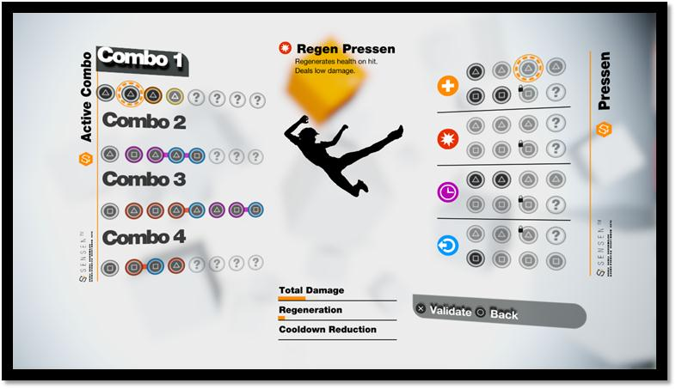 **Overview**

Remember Me’s ComboLab allows you to create and customise your own bespoke combos by unlocking new fighting move memories and combining them to maximise their power.

The ComboLab provides a second layer of depth to the game’s combat system, with the goal of encouraging players of all abilities to experiment with different combinations and find the best combo for each combat situation.

The ComboLab is accessible via the pause menu at any given moment in the game.

1. **Combo list**

There are **four combo sequences** available. Each sequence consists of several slots delivering either kick or punch attacks. The sequence is predetermined, but you are able to assign the type of kick or punch move, known as *‘Pressens’*, for each slot in the sequence.

Each Combo starts with a standard attack highlighted below in **orange**. The other slots are empty until you fill them with *Pressens* (see next chapter).

At the beginning of the game, some **combos’ slots** are locked. The more Nilin fights the more Nilin remembers her melee combat skills and further slots become unlocked.

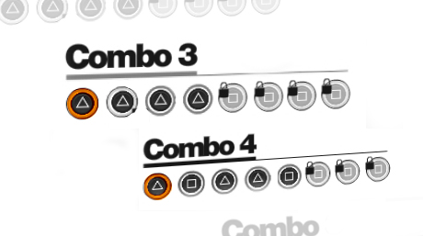

1. **Pressens**

Before her memory was erased, Nilin was a very powerful fighter. Progressively, she will have to remember all the moves she once knew.

In Remember Me, these fighting moves are called ***Pressens***. These are the memories which need an amount of **Procedural Mastering Power** (PMP) in order to be remembered.

PMP is gained by defeating enemies and performing combos. The longer the combo you perform, the more PMP you earn.

There are **24 *Pressens*** in the game. There are four **families** of Pressens; each family has a unique power that lies within.

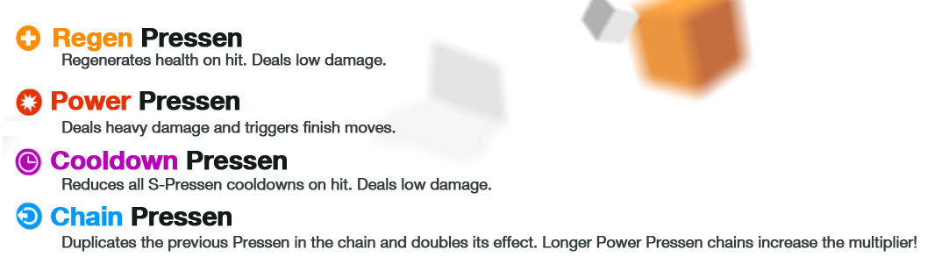

1. **Customization & strategy**

There are many different ways to combine Pressens in order to create powerful and personalized combos. Depending on the combinations selected, you can **setup different strategies** which respond to various fight situations. The effect that each Pressen delivers will be rewarded instantly.  
Here are some examples:

1. **Basic strategies: Add/Remove/Replace**

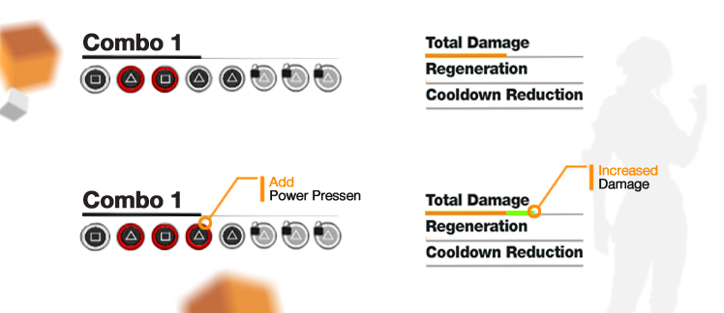By just **adding** a new Pressen into a combo, you greatly improve its efficiency. In the below combo, only the first three hits (🞏 Δ 🞏) are assigned. The unassigned Pressens will not be part of the combo. Adding a fourth Pressen, in this case to the second Δ, will activate this fourth part of the combo. The final three parts of this combo are still locked as they have yet to be remembered by Nilin.

*Example:*

By **combining** different Pressens types into a single combo you can create **multi-usage combos**.

A Pressen will be **more or less efficient** depending on its **position within a combo**: the later the Pressen appears within the combo, the more efficient it will be. In the example below you can see how swapping the position of two different Pressens alters their effectiveness.

*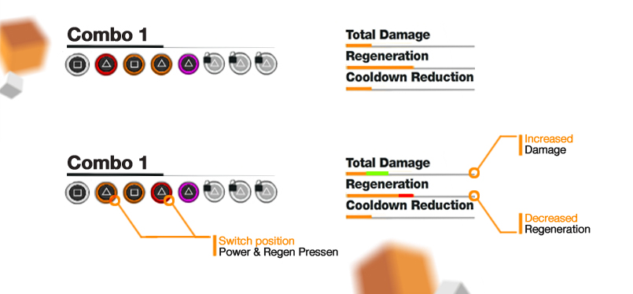Example:*

Based on these two actions, (add/remove or combine), you can create different kinds of strategy: short versus long combo / single versus mixed Pressens family.

1. **Advanced strategies: Chain Pressen**

A allows you to **duplicate** the previous Pressen in the chain and **doubles its effect**. Thanks to this, you will be able to create very powerful combos but beware; there are just **a few of them** so you’ll have to choose carefully which combo chain you want to boost.

*Example:*

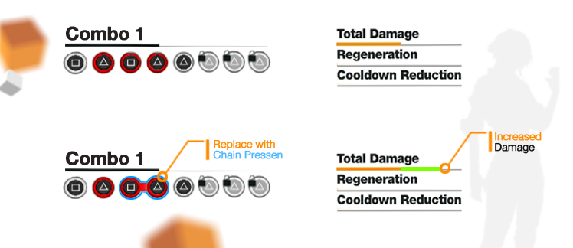

You can also create a chain of Chain Pressens to **increase the multiplier**.

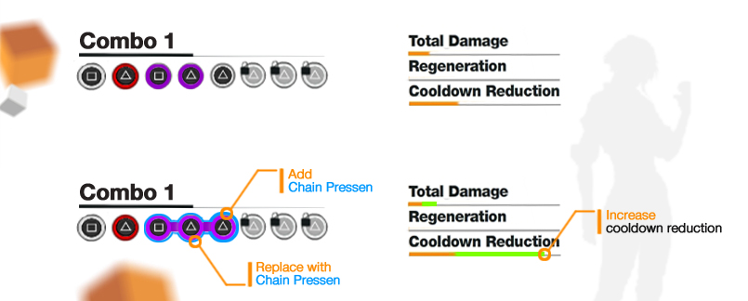

1. **Dynamic Combo Display**

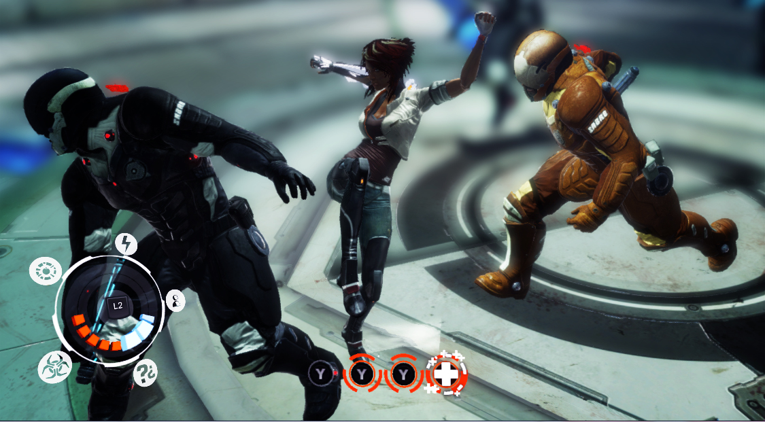The dynamic combo display is in-game real time feedback of your combos. It indicates the input you press (kick or punch) and the Pressen family.

1. **S-Pressens**

S-Pressens are **unique moves** which enable the player to turn the tide of battle.

S-Pressens are not directly linked to the ComboLab as you cannot place them in a combo chain or buy them. However you need to **perform several combos** to build a resource called **“Focus”**. Focus is gained each time Nilin hits or is hit by an enemy. With enough Focus stored, Nilin will be able to unleash one of her amazing powers.

There are **five S-PRESSENS** in the game, which will be unlocked throughout the story. Each of them is a destructive weapon dedicated to take care about all sort of enemies:

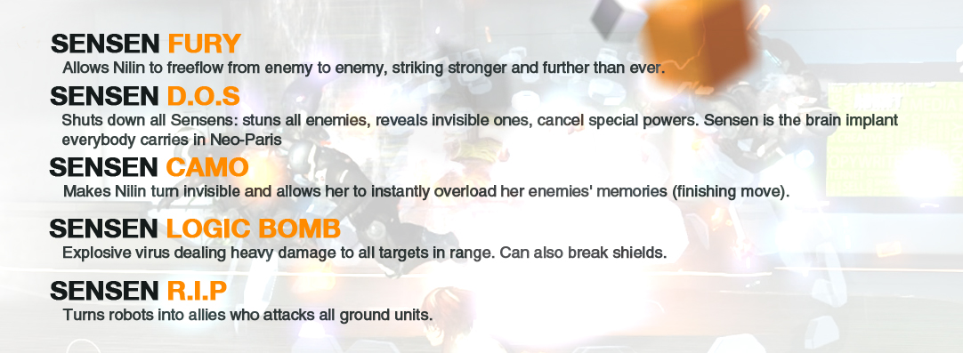

The **Senwheel** is the name of the interface displaying both focus gauge and S-Pressens. By **Pressing L2/LT**, you enter in the S-Pressen selection mode.

